Must Know JAVA concepts | Selenium Automation | PART - 1 | Working with Databases

Working with databases is one of the most important and critical operations which every selenium automation developers must know. There are variety of databases available on the market like MySQL, Oracle SQL, MS-SQL and so on. Almost all the relational database management systems (RDBMS) are more or less the same. The Java code varies a bit for each database.

What will we learn in this video:

1. Why database testing is important?

2. What is database testing?

3. How to use Java for testing our database?

4. Java MySQL connection.

Installation Reference links: ---------------------------------------------

1)Download URL for XAMPP - https://bit.ly/1lmUscR

2) How to install Xampp - • How to Install XAMPP Server on Windows 10

3) Create database and table in MySQL - • create a database with xampp

4) JDBC connector Jar for MySQL - https://bit.ly/2VXDEl2

We can install MySQL, Oracle SQL, MS-SQL & proceed..but we are following the same approach as the trainer

Installing XAMPP

Must Know JAVA concepts | Selenium Automation | PART - 2 | File Writing Operations

Writing a file is one of the basic and the most important thing expected out of any automation and java developer. File writing can be done in several ways. like File Writer, Buffered Writer, FileOutputStream and Path. Each way has its own advantage and disadvantages.

What will we learn in this video:

1) What is file writing?

2) How to do File writing in Java?

3) Different Ways to do File writing in Java?

4) Advantages and disadvantages

Filewriter-> straight forward, direct interaction with file, less performance

Bufferedwriter-> Easiest way , best performance, widely used

Fileoutputstream-> for writing raw byte array information (eg images)

Path-> also writing byte array

Filewriter-> straight forward, direct interaction with file, less performance

package Filewriting;

import java.io.FileWriter;
import java.io.IOException;

public class Usingfilewriter {

public static void main(String[] args) throws IOException {
// TODO Auto-generated method stub

String location = "filewriter.txt";
String content ="Testing purpose";

FileWriter fileWriter = new FileWriter(location);
fileWriter.write(content);
fileWriter.close();
}

}

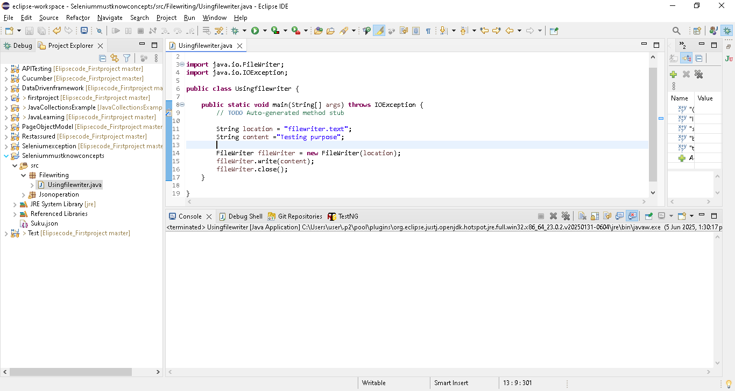

Refresh the project , filewriter.txt present under project

String location = "filewriter.txt";..

Note: here we have given only name, so default it will create under project..

If we give “C:/ filewriter.txt” then it will store under c drive

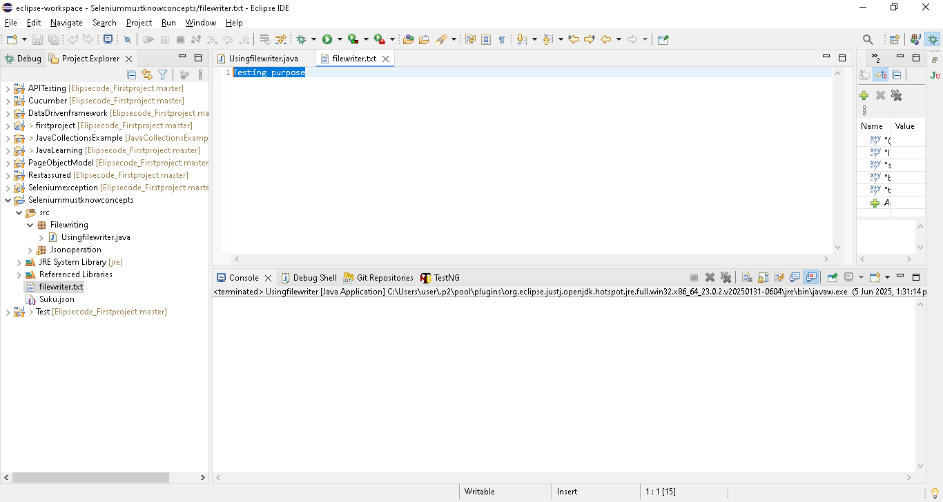

Bufferedwriter-> Easiest way , best performance, widely used

Filewriter always direct interaction with file, so cost involve while writing in any file

So using Bufferedwriter -> like a garbage & only store at the last in the file..something like that

package Filewriting;

import java.io.BufferedWriter;
import java.io.FileWriter;
import java.io.IOException;

public class Usingbufferedwriter {

public static void main(String[] args) throws IOException {
// TODO Auto-generated method stub
String location = "Bufferedwriter.txt";
String content ="Testing purpose";

FileWriter fileWriter = new FileWriter(location);
BufferedWriter bufferedWriter = new BufferedWriter(fileWriter);
fileWriter.write(content);
fileWriter.close();
}

}

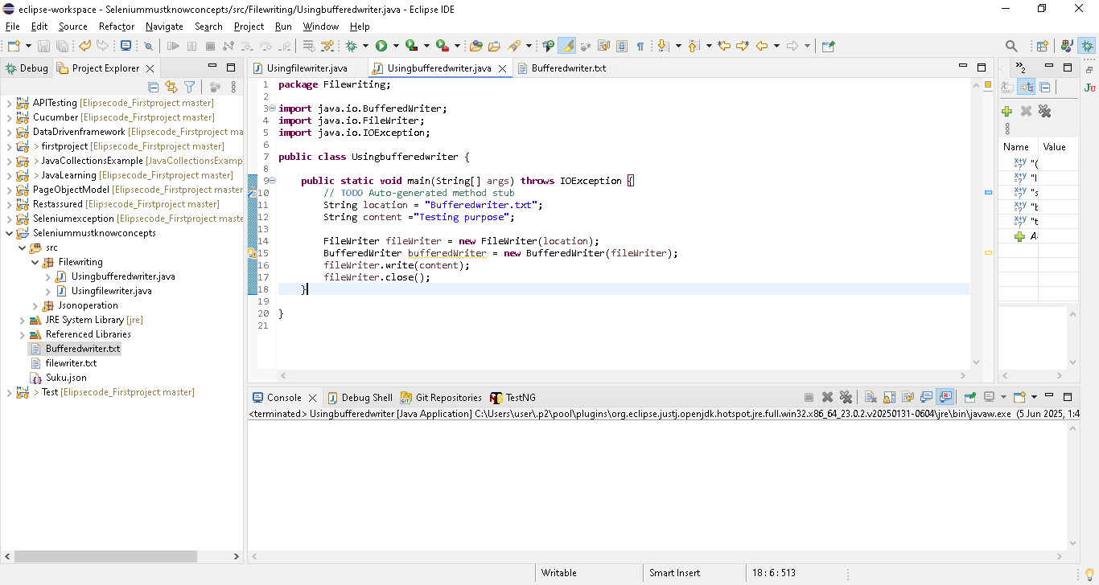

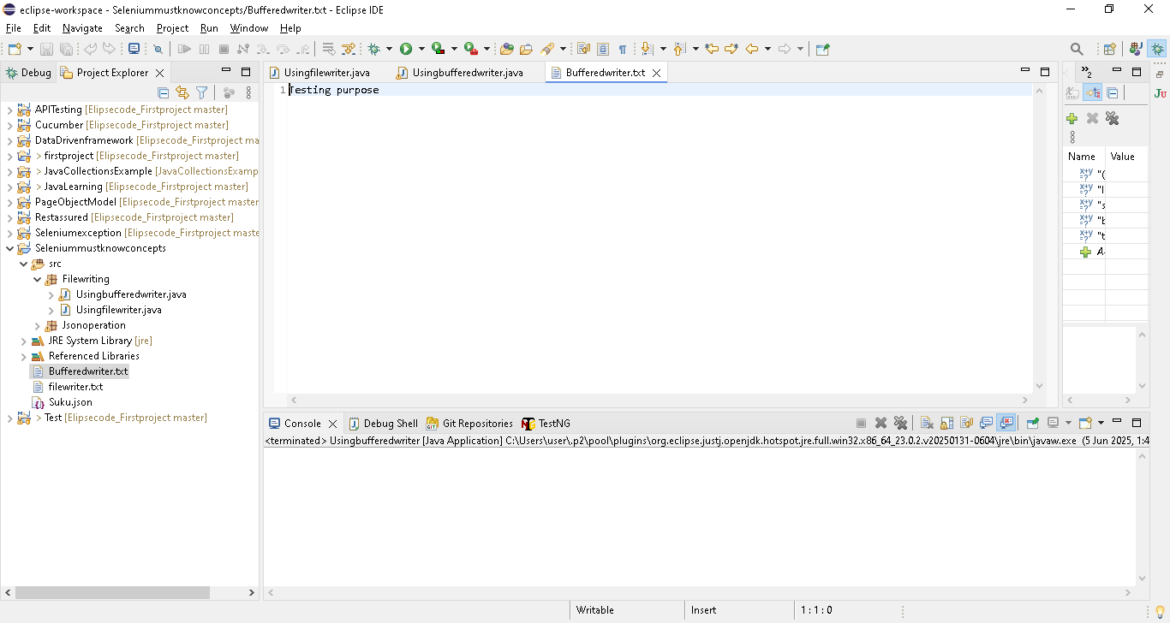

Fileoutputstream-> for writing raw byte array information (eg images)

package Filewriting;

import java.io.BufferedWriter;

import java.io.FileInputStream;

import java.io.FileOutputStream;

import java.io.FileWriter;

import java.io.IOException;

public class Usingfileoutputstream {

public static void main(String[] args) throws IOException {

// TODO Auto-generated method stub

String location = "fileoutputstream.txt";

String content ="Testing purpose";

FileOutputStream fileWriter = new FileOutputStream(location);

byte[] bs = content.getBytes();

fileWriter.write(bs);

System.out.println(bs);

}

}

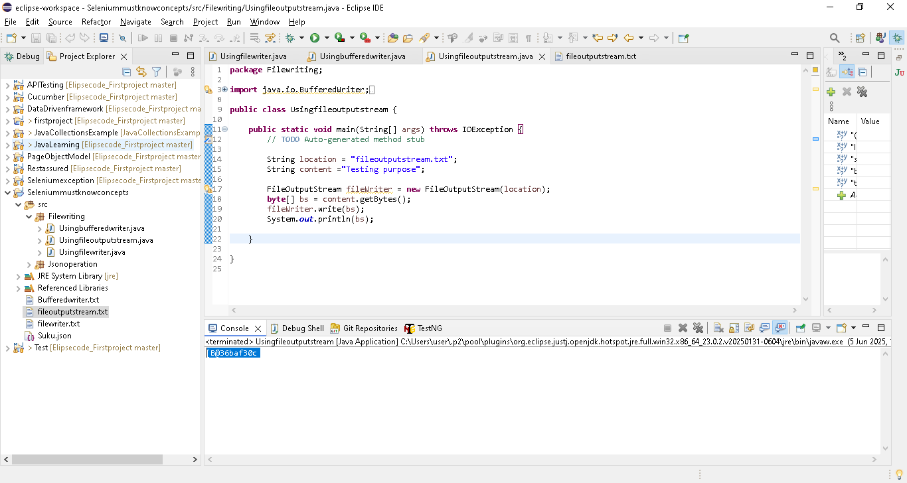

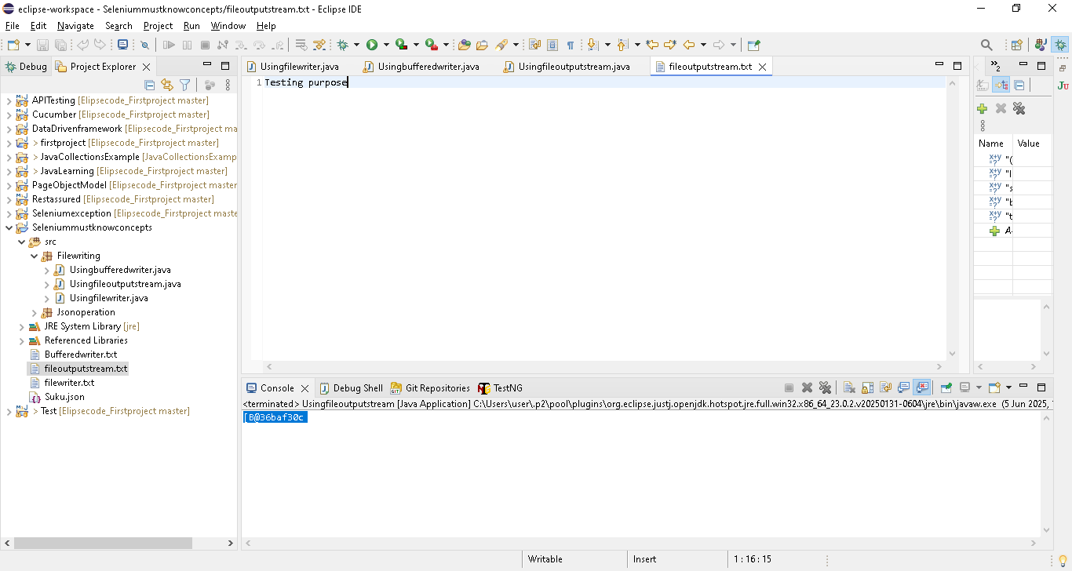

Path-> also writing byte array

package Filewriting;

import java.io.IOException;
import java.nio.file.Files;
import java.nio.file.Path;
import java.nio.file.Paths;

public class usingPath {

public static void main(String[] args) throws IOException {
// TODO Auto-generated method stub

String location = "Path.txt";
String content ="Testing purpose";

//path is interface here
Path path = Paths.get(location);
Files.write(path, content.getBytes());

}

}

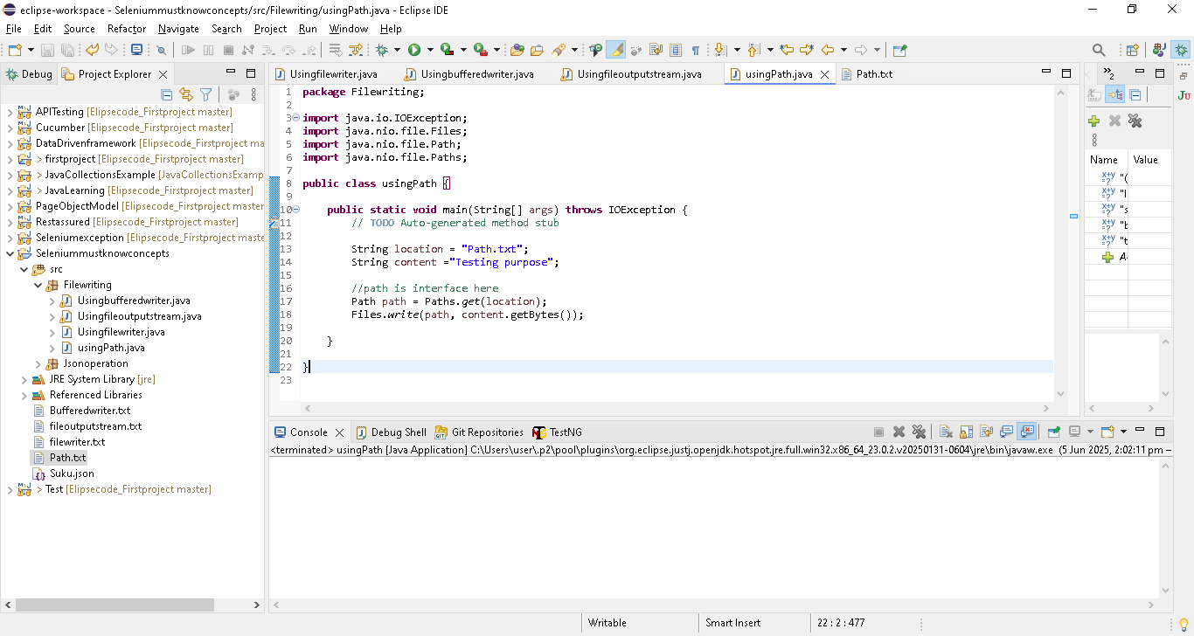

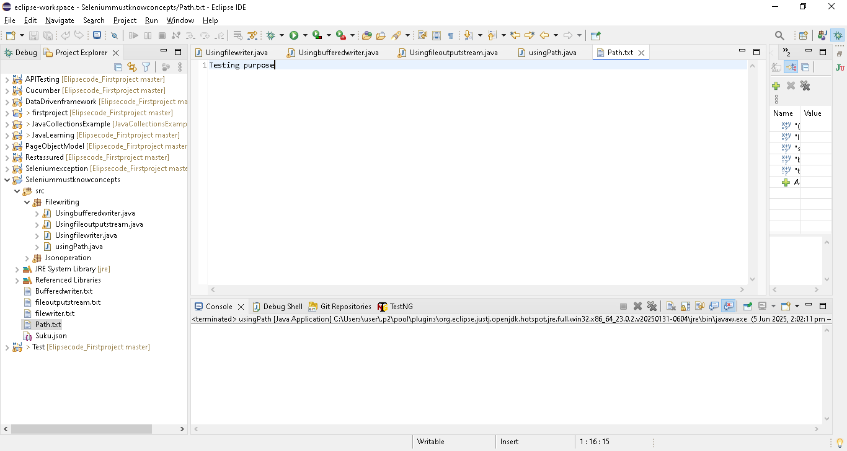

There are 7 to 8 ways to file writing..but above 4 is enough & mostly used

Must Know JAVA concepts | Selenium Automation | PART - 3 | File Reading Operations

Reading a file is one of the basic and the most important thing expected out of any automation and java developer.

What will we learn in this video:

1) What is file reading?

2) How to do File reading in Java?

We have no of option to read the files..in that we are going to see bufferreader its a easy way n widely used

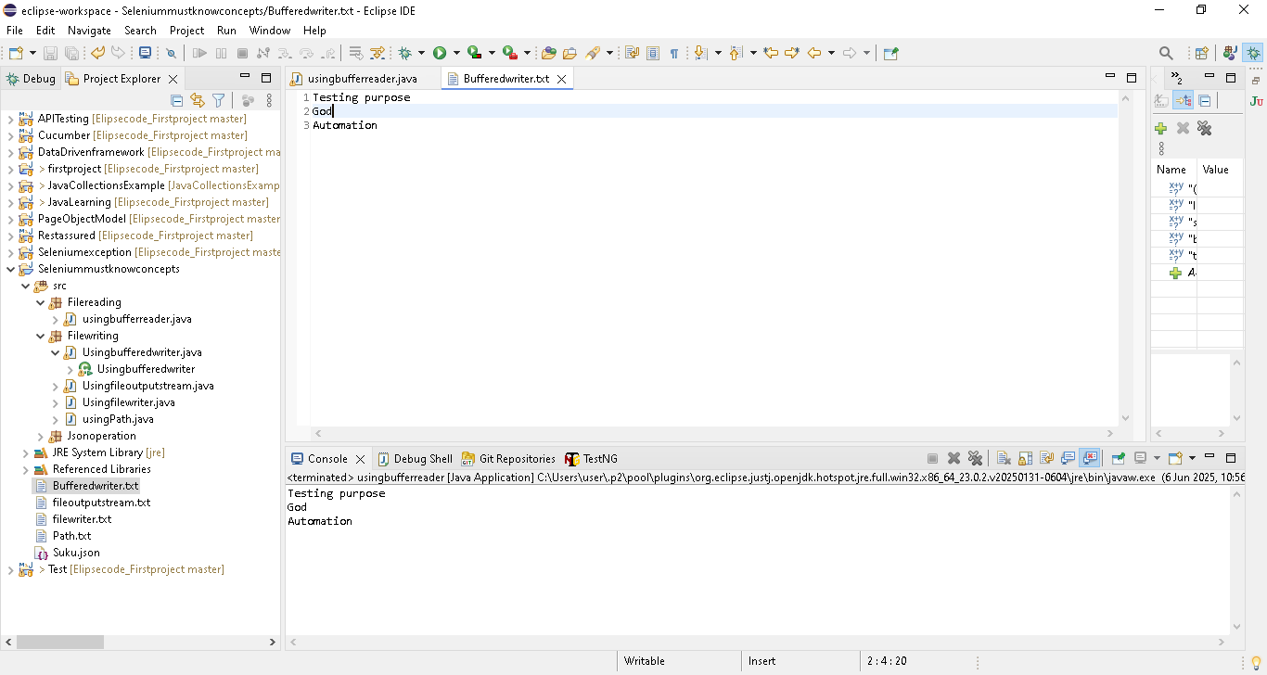

package Filereading;

import java.io.BufferedReader;
import java.io.FileReader;
import java.io.IOException;

public class usingbufferreader {

public static void main(String[] args) throws IOException {
// TODO Auto-generated method stub
String location = "Bufferedwriter.txt";

FileReader fileReader = new FileReader(location);
BufferedReader bufferedReader = new BufferedReader(fileReader);
String readeddata;

while ((readeddata = bufferedReader.readLine())!=null) {
System.out.println(readeddata);
}
}

}
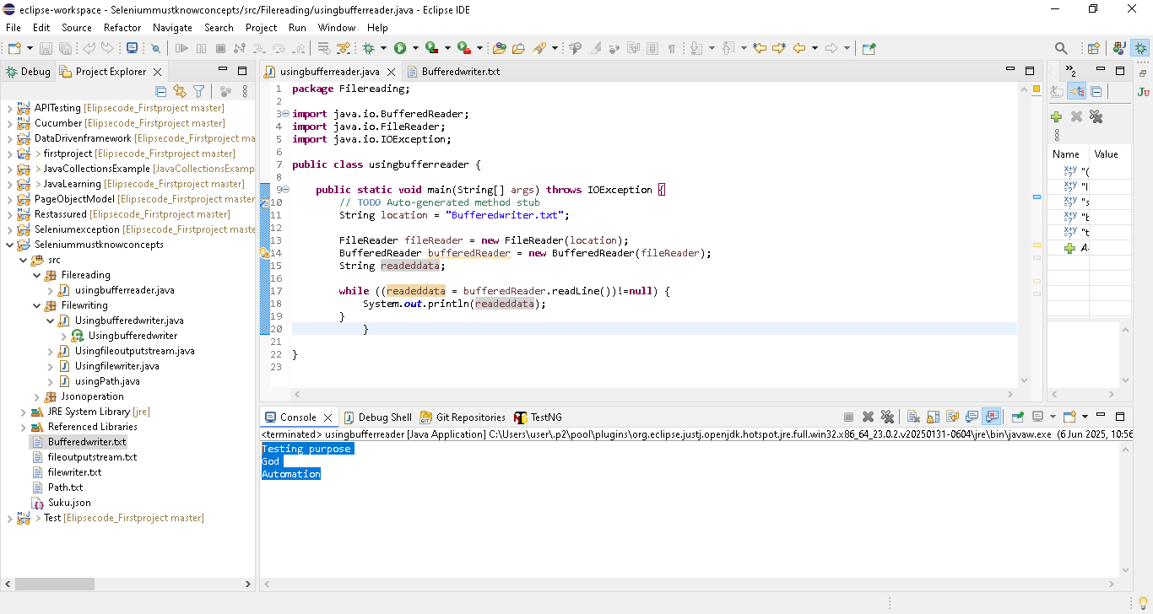

Must Know JAVA concepts | Selenium Automation | PART - 4 | Config Property File Reading

So far in this channel, we have given all the input values as hardcoded ones. Hardcoding the values is one of the biggest threat to any programming. This will make our code unmaintainable over a period of time. Selenium code is also not an exception from this. There are plenty of input values we may have to give to our test cases, we should not hardcode them. We have to make them configurable. In order to make the input values configurable, Java has a class called Properties. This property class stores the input as KEY VALUE pair. This is one of the most important concepts and this is needed while creating a live selenium project.

What will we learn in this video:

1. Why do we need to read a property file?

2. What is a property file?

3. How to read a property file using Java?

Once the project is ready, and you need to share the project to client , & he will execute..

Client need to execute in her machine..in that chrome driver path need to share as per client location and also he want to run in firebox instead of chrome..

For this and all we are using Config.Property concepts..so we are keeping the location and which driver outside..just client need to update the value in Config.Property[like key and value]

Right click the project & create a file as config.properties

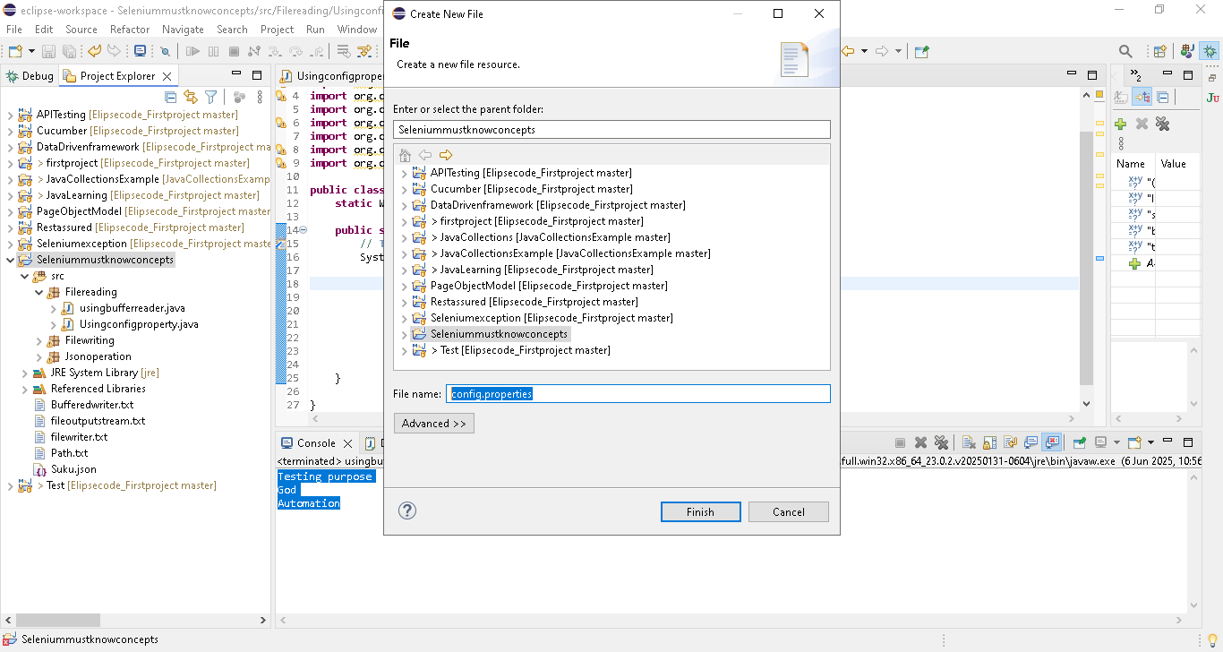

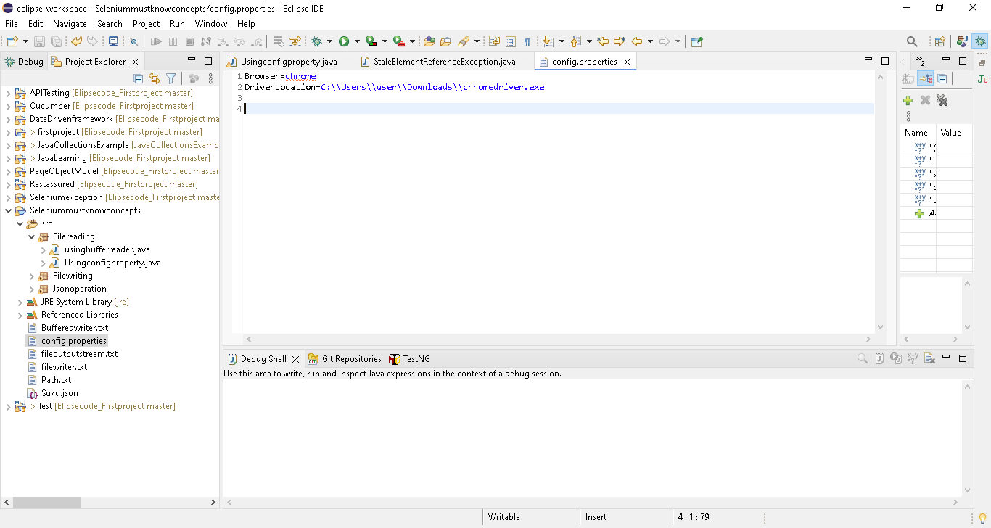

Browser=chrome
DriverLocation=C:\\Users\\user\\Downloads\\chromedriver.exe

Browser ->Key

Chrome ->Value

Go to code and read the value from config

package Filereading;

import java.io.FileInputStream;
import java.io.IOException;
import java.util.Properties;

import org.openqa.selenium.By;
import org.openqa.selenium.Keys;
import org.openqa.selenium.WebDriver;
import org.openqa.selenium.WebElement;
import org.openqa.selenium.chrome.ChromeDriver;
import org.openqa.selenium.firefox.FirefoxDriver;
import org.openqa.selenium.support.ui.ExpectedConditions;
import org.openqa.selenium.support.ui.WebDriverWait;

public class Usingconfigproperty {
static WebDriver driver;

public static void main(String[] args) throws IOException {
//using FileInputStream to get the config.properties file
FileInputStream fileInputStream = new FileInputStream("config.properties");
//create a object for Properties & using load method
Properties properties = new Properties();
properties.load(fileInputStream);
//using getProperty(key) to read the value
String browser = properties.getProperty("Browser");
String diverlocation = properties.getProperty("DriverLocation");

//based on the config file, it will point to particular driver & driver location
if(browser.equalsIgnoreCase("chrome")) {
System.setProperty(
"webdriver.chrome.driver",
diverlocation);
driver = new ChromeDriver();
} else {
System.setProperty(
"webdriver.gecko.driver",
diverlocation);
driver = new FirefoxDriver();
}

driver.manage().window().maximize();
driver.get("http://www.google.com/");

}

}

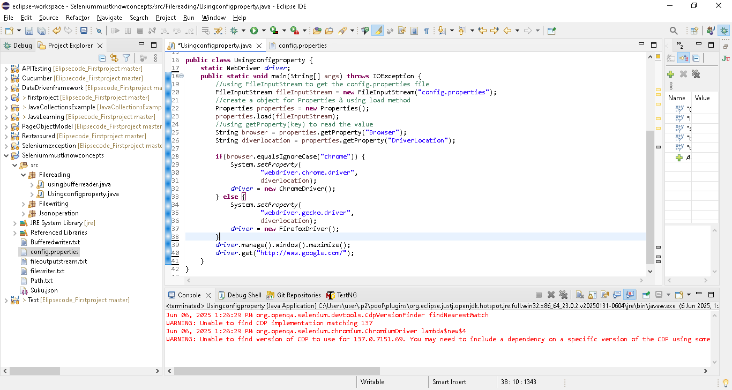

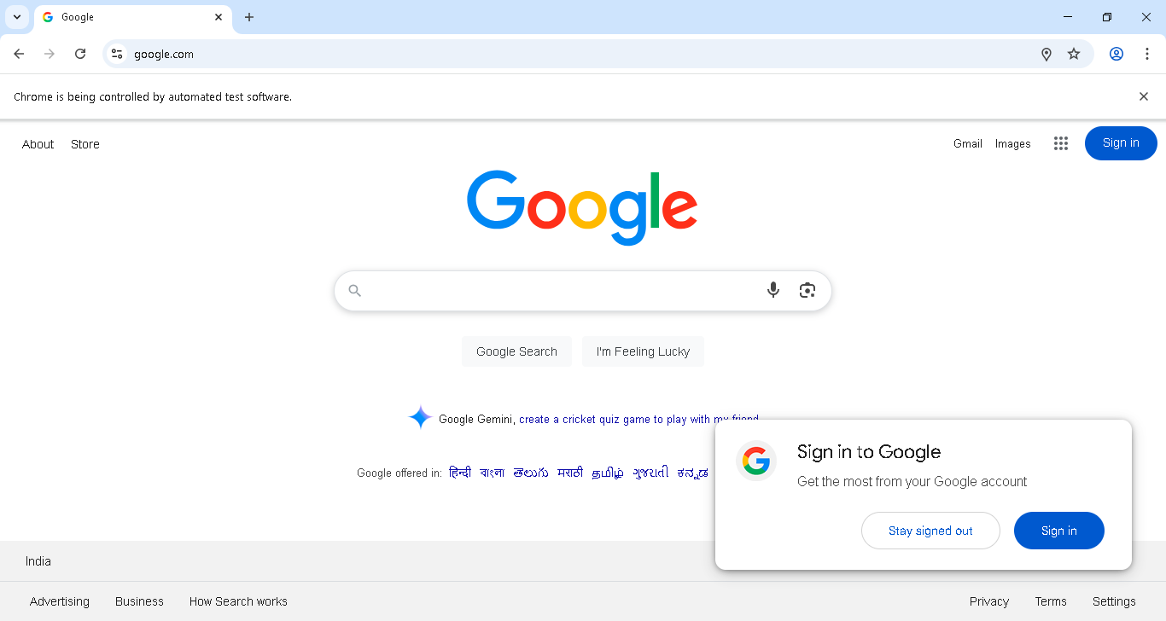

If we need to run in firebox or edge, then just update the config file

Must Know JAVA concepts | Selenium Automation | PART - 6 | JSON Introduction | Writing JSON in Java

What is a JSON File? -----------------------------------

JSON stands for JavaScript Object Notation. JSON file contains,JSON Objects with .json file extension.

In this modern era, we have a lot of programming languages. Almost all of us use different web services in our daily life (Eg. Weather report, currency conversion, enquiring Gold rates, cricket scores). Our browser is the point of contact, to make the request to the server, receive the response from the server, process the response and render it to the user. A web server may be implemented with any programing language like Java, python etc.

Our browser can understand Javascript. So there has to be a common, language-independent data transmission between a web application and a web server.

Why JSON? ---------------------

1) JSON is a lightweight data-interchange format

2) JSON is "self-describing" and easy to understand

3) JSON is language independent

What will we learn in this video:

1. JSON Introduction

2. Libraries needed for writing JSON using Java (JSON simple, Jackson, GSON)

3. Steps to writing the JSON file using Java

4. File writer in Java

Json-simple Jar download link: https://bit.ly/2RDNlXb

A simple JSON file structure [key:Value] age ->key & 1 ->values
{
“age”: 1, ->number so without double quotes
“name”: “Agni”, ->string so with double quotes
“Special features”: [“Magical Smile”,”magnetic eyes”] ->[] array contain 2 values
}
Steps to write a JSON
Pre-requisite : Download and add the JSON – simple jar in your project
Path->https://mvnrepository.com/artifact/com.googlecode.json-simple/json-simple/1.1.1
Or
https://code.google.com/archive/p/json-simple/downloads
1.Create jsonobject
2.Add key value using put()
3.if jsonarray is needed, then create object for jsonarray & then add the elements to it
4.to add the json array to json object , use same put()
5. to write this json to a file, use file writer

https://code.google.com/archive/p/json-simple/downloads
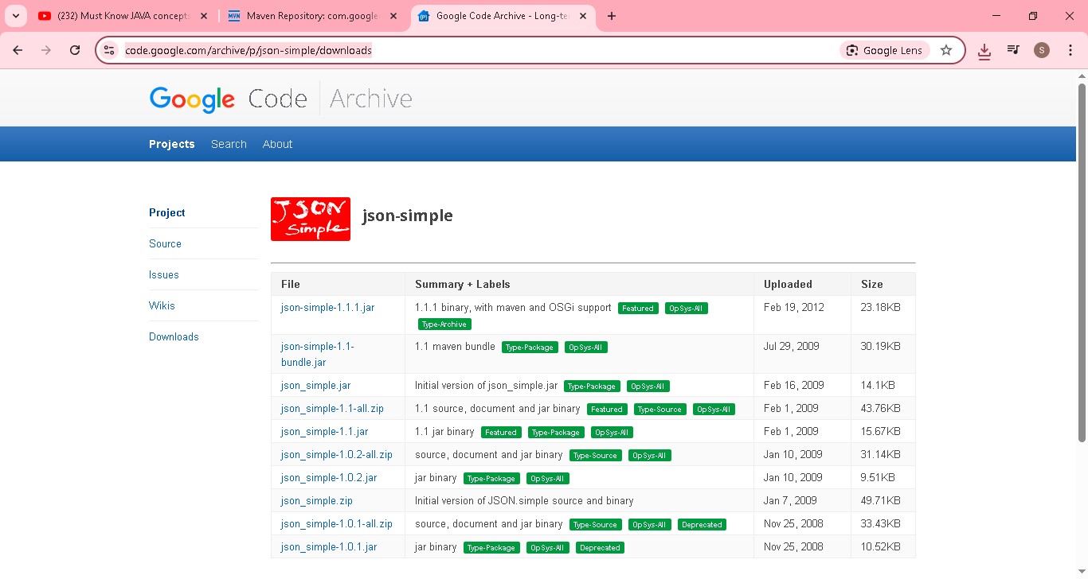

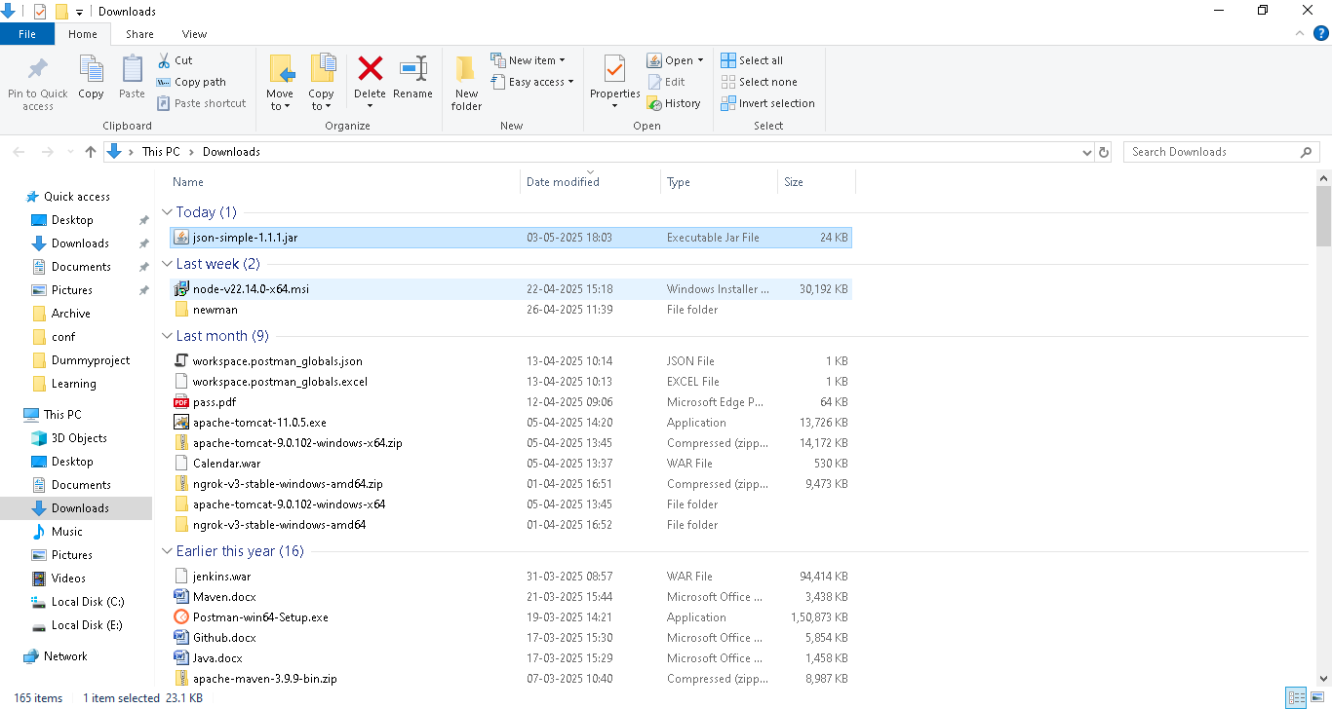

Create a simple project & add the above jar in library
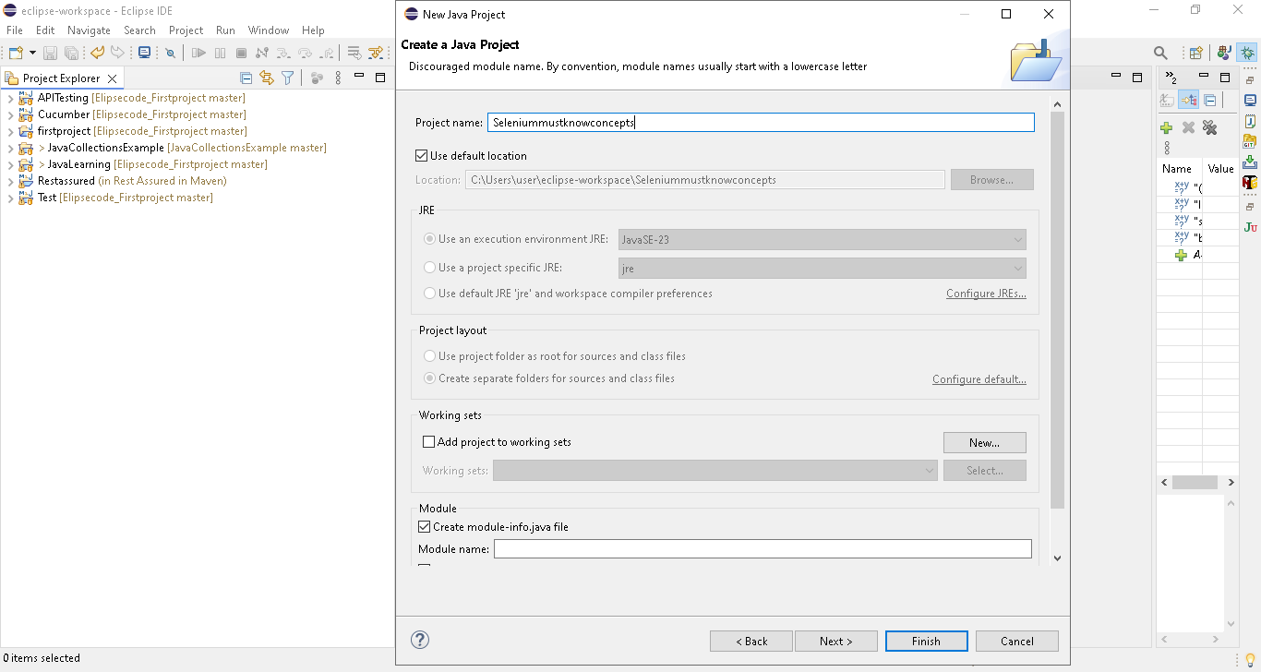
Create package
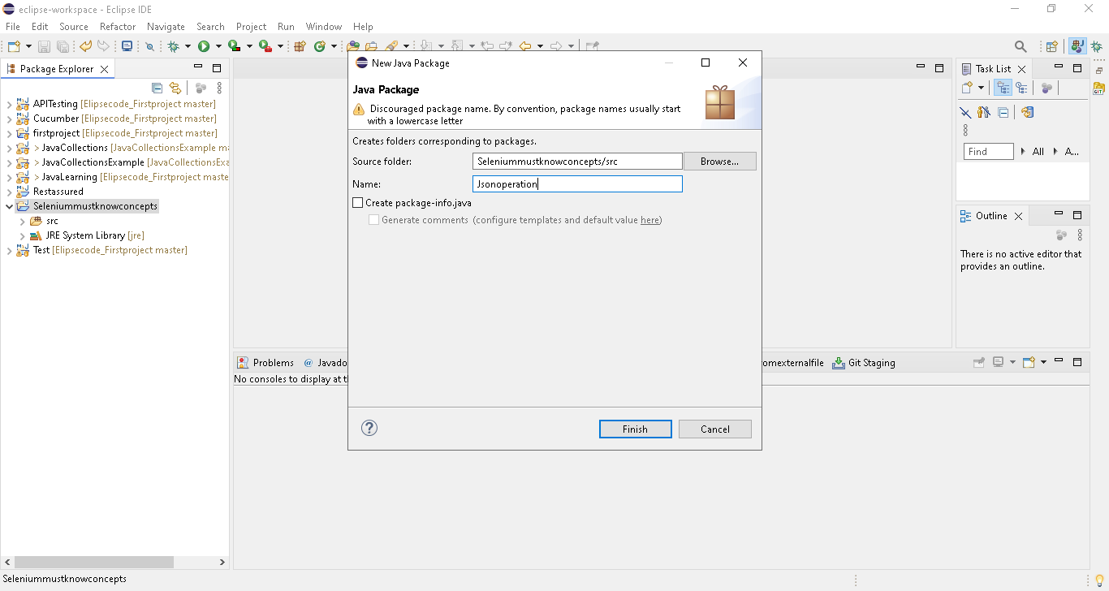

Create class
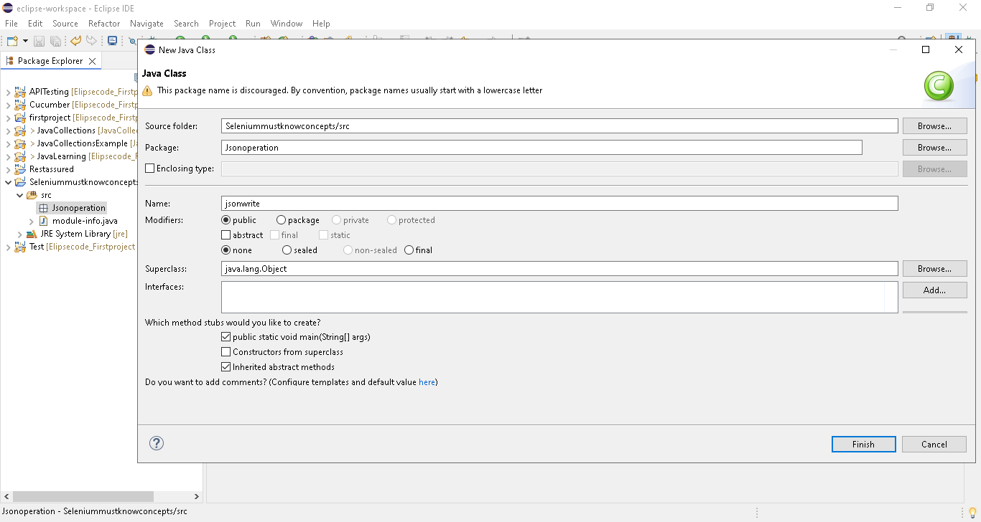

Add jar file
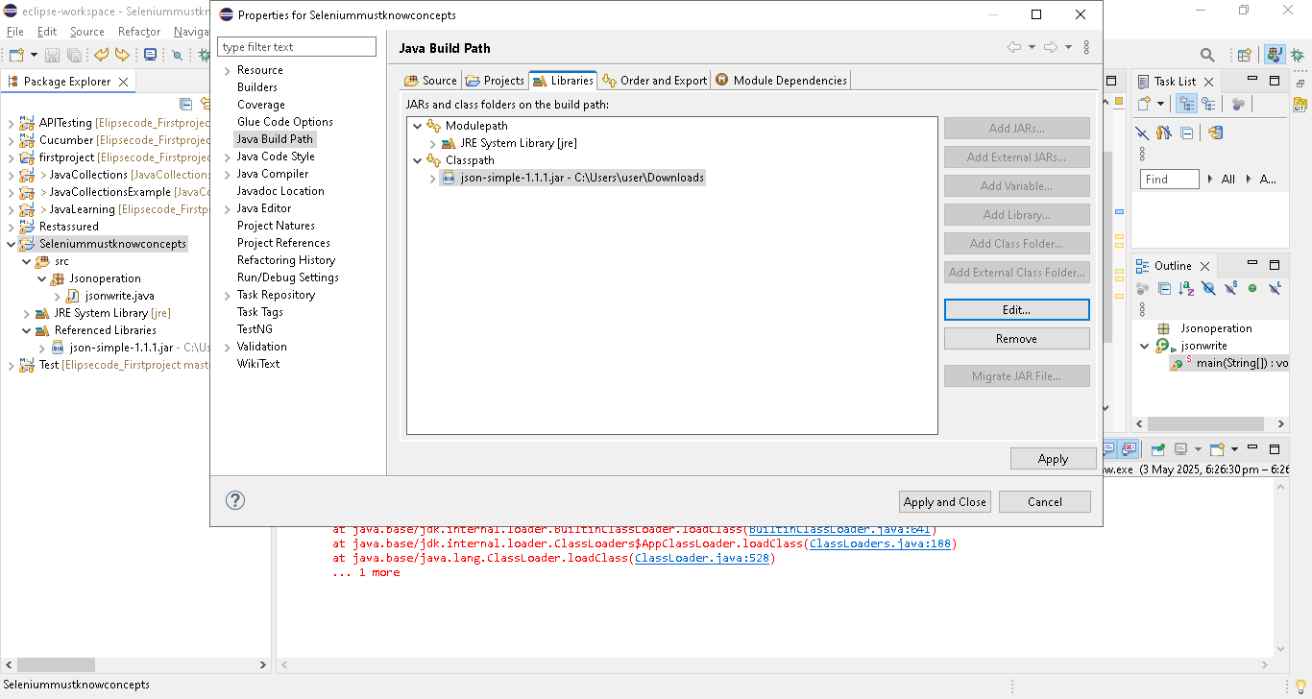
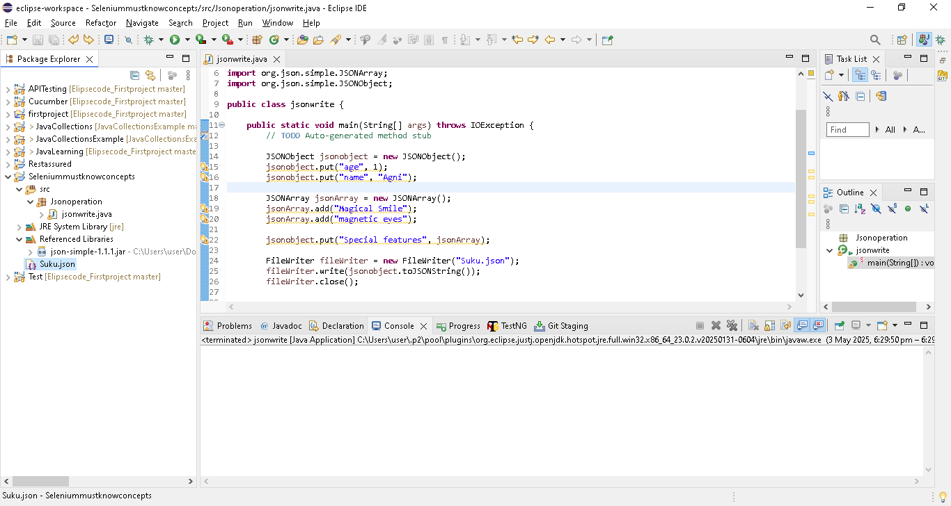
package Jsonoperation;

import java.io.FileWriter;
import java.io.IOException;

import org.json.simple.JSONArray;
import org.json.simple.JSONObject;

public class jsonwrite {

public static void main(String[] args) throws IOException {
// TODO Auto-generated method stub

JSONObject jsonobject = new JSONObject();
jsonobject.put("age", 1);
jsonobject.put("name", "Agni");

JSONArray jsonArray = new JSONArray();
jsonArray.add("Magical Smile");
jsonArray.add("magnetic eyes");

jsonobject.put("Special features", jsonArray);

FileWriter fileWriter = new FileWriter("Suku.json");
fileWriter.write(jsonobject.toJSONString());
fileWriter.close();

}

}

Run as java application & suku.json create & present under project[left side]
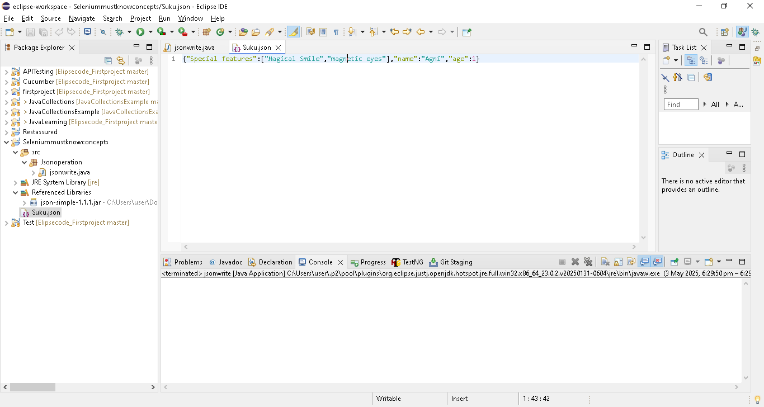

Must Know JAVA concepts | Selenium Automation | PART - 7 | JSON | Reading JSON in Java

What we will learn in this video:
1. Steps to read the JSON file
2. Typecasting in Java
Steps to read a JSON
1. Create object for json parser
2.File reader ->read from suku.json file
3.Parse the read file using parse() & store it in object
4.to get the values from parsed object use get(). But to do that, we have to convert the object to Json object.
5. now use, get() with key
To retrieve name and age and store them after type casting
6. To fetch data from json array, use iterator() & iterate them and print

package Jsonoperation;

import java.io.FileReader;
import java.io.IOException;
import java.util.Iterator;

import org.json.simple.JSONArray;
import org.json.simple.JSONObject;
import org.json.simple.parser.JSONParser;
import org.json.simple.parser.ParseException;

public class jsonread {

public static void main(String[] args) throws IOException, ParseException {
// TODO Auto-generated method stub

//1. Create object for json parser
JSONParser jsonParser = new JSONParser();
//2.File reader ->read from suku.json file
FileReader fileReader = new FileReader("Suku.json");
//3.Parse the read file using parse() & store it in object
Object parsedobject = jsonParser.parse(fileReader);
//4.to get the values from parsed object use get().
//But to do that, we have to convert the object to Json object
JSONObject jsonobject = (JSONObject) parsedobject;
//5. now use, get() with key
//To retrieve name and age and store them after type casting
String name = (String) jsonobject.get("name");
//Note. in json always consider number as Long not integer..so used Long
Long age = (Long) jsonobject.get("age");
System.out.println("The name is" +name);
System.out.println("The age is" +age);

//6. To fetch data from json array, use iterator() & iterate them and print
JSONArray array = (JSONArray) jsonobject.get("Special features");
Iterator iterator = array.iterator();
while(iterator.hasNext()) {
System.out.println("Special features is" + iterator.next());
}

}

}
